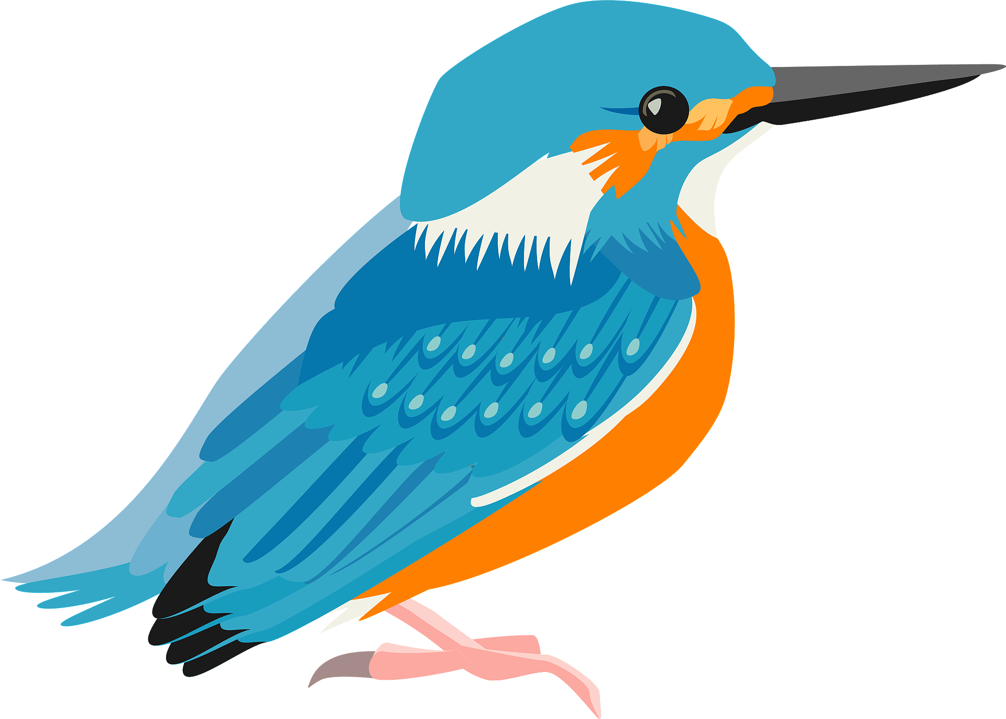



Welcome to Kingfisher class!
This term our topic is called:
All Are Welcome

Phonics and Reading
Phonics is a key part of our learning in year R. We will be starting by learning our initial sounds starting with s,a,t,p,i,n. Please join us for our reading meeting to find out more.
Later in the term, we will start sending out reading books. We will give further information about this via Tapestry nearer the time.
Please see our website for further information on our curriculum.
https://www.chattenden.medway.sch.uk/page/?title=Global+Curriculum&pid=44
Welcome to Kingfisher Class.
We are so excited to welcome you and your child to Kingfisher Class.
Your child will be supported by the EYFS team Mrs Dhdwal, Mrs Underhay and Mrs Stewart.

Dates for your diary:
- 16th September- Reading Meeting
- 24th September – School Photo Day
14th October – Harvest Festival
14th and 16th October – Parents Evening
- End of term 1



Outdoor learning
In EYFS, we access the outside environment in all weathers. To enable your child to enjoy learning in the outdoor environment, they will need a warm, waterproof coat, marked with their name in school every day. Please could you support your child in zipping up their coats by themselves.

Help and support
Every year we look to enhance our learning areas both inside and out. If you have any, or know of anyone with plastic pipes, guttering, pine cones, conkers, small logs or log slices we would be very grateful if you would consider donating them to our class. We would also appreciate any teas sets, tea pots, metal jelly mould, metal jugs, tea strainers or gravy boats. Thank you for your support!
PE
Our PE day this term is Wednesday. We will not yet be getting changed so please do not worry about buying PE kits yet. They will need to take shoes and socks of, however, so it would be beneficial to practice this with your child at home.

