
Year 5
Panther Class

Please find more information about the year 5 curriculum here: https://www.chattenden.medway.sch.uk/page/?title=Global+Curriculum&pid=44

Dear Parents/Carers,
Welcome to year five! We are all anticipating a wonderful, fun and engaging year ahead. Our first Global Theme is centred around ‘Sustainable Development’. Over the term, children will explore the theme of environmental leadership. This involves looking at the impact of our actions on the environment and how we can change this through adopting new points of view and perspectives on how we damage the world. They will focus on the changes that can be made to improve this and create an advert that will bring awareness to the issues they have found through research. In addition, the geographical landscape will be explored, with natural disasters forming the basis of their research, and this will give a context to why the effects must be reversed.



Zane Dupree is a charismatic 12-year-old boy of mixed race visiting a relative in New Orleans when Hurricane Katrina hits. Unexpectedly separated from all family, Zane and his dog experience the terror of Katrina's wind, rain, and horrific flooding.

Core Text
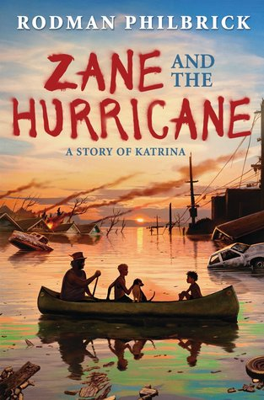

Home Learning
Your support to your child and the school is greatly appreciated and we rely on this support to ensure your child achieves their potential. Home learning will be sent out each Friday and is due in the following Friday.
Homework will be set on PURPLE MASH. This will include one maths, GPAS and reading task (serial mash). All children will be able to access Purple Mash through the internet on any device or the Purple Mash app. Hopefully this will be an engaging way to consolidate learning in a fun and interactive way. If any child does not have the ability to access Purple Mash, we will provide them the opportunity to access the work at school. If there are any issues please let me know.
Please encourage your child to go on Times Table Rock Stars, Purple Mash, SPAG.com and Maths.co.uk. The expectations for reading have greatly increased in Key Stage 2 over the last few years, so please could your child also read for at least 20 minutes every night and note this in their reading record book.





Thank you for your continued help and support. Any questions, please don’t hesitate to get in touch.
General Information
- PE for Term 1 is on Thursday – full kit
- Spelling test - Friday

